## horizontal line

Self Balancing Bicycle

# Overview

The Automatic Balancing bicycle will employ a control system to keep itself from falling over while in motion, and be propelled by a motor. The goal of this project was to build a two inline-wheel bicycle prototype capable of balancing itself using a reaction wheel. This robotic bicycle is able to drive and also come to a complete stop without losing its balance.

# Components:

1. AT mega 16
2. Flywheel (metallic reaction wheel)
3. ADXL335 Triple axis accelerometer
4. L298N motor driver
5. IDG500 dual axis gyroscope
6. High torque 24V DC motor

# Working:

The flywheel is mounted on an axis parallel to the length of the bicycle. As the bicycle tilts, a motor applies a torque to the flywheel, which applies a reactionary torque on the bicycle to re-balance. A microcontroller implements a PID control algorithm based on the measured tilt angle to determine the required torque for the motor to apply to the flywheel.

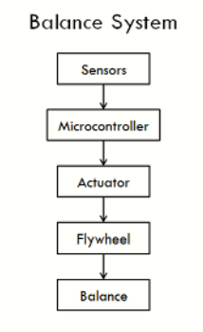

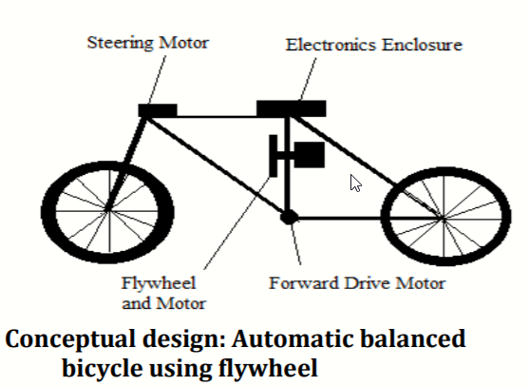

**Applications:**

1. Such a system could be used both as a teaching tool, and as a physically therapeutic device.
2. Self balancing bicycle would be a better choice for the short distance travelling purpose, avoiding environmental issues.